KAWS HIGH SCHOOL BOYS BASKETBALL CAMP
GRADES 9-12
JUNE 3rd-5th, 9:00-10:30am
@ High School GYMNASIUM
COST: $40
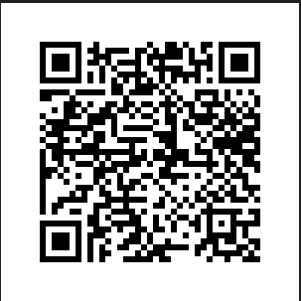
You may use the QR code to sign up, or you may use the form below.

9-12th GRADE KAWS HIGH SCHOOL BASKETBALL CAMP REGISTRATION FORM

PLAYER NAME__________________________________________ 2024-2025 GRADE______________

PARENT/GUARDIAN___________________________________PHONE:____________________________

ADDRESS:____________________________________________________________________________________

SHIRT SIZE:________________________

**EMERGENCY CONTACT INFORMATION**

NAME____________________________________________________ PHONE:____________________________

IN CONSIDERATION OF YOUR ACCEPTANCE OF MY ENTRY, I HEREBY, FOR MYSELF, MY HEIRS, EXECUTORS OR ADMINISTRATORS: WAVE ANY RIGHTS OR CLAIMS FOR DAMAGES I MAY HAVE AGAINST PERRY-LECOMPTON HIGH SCHOOL, USD#343, SCHOOL BOARD, SCHOOL STAFF, CAMP INSTRUCTORS OR PERRY-LECOMPTON BASKETBALL. I ALSO REALIZE THAT BASKETBALL IS A HIGH-RISK ACTIVITY AND I COULD BE INJURIED. I CERTIFY THAT I AM IN GOOD HEALTH AND HAVE NO SERIOUS HEALTH PROBLEMS. I HEREBY VERIFY BY MY SIGNATURE AND/OR ENROLLMENT IN THIS CAMP.

STUDENT:________________________________________________DATE:_____________________________

PARENT/GUARDIAN:______________________________________________DATE:__________________
*PLEASE DETACH THIS SECTION OF YOUR FORM ALONG WITH YOUR PAYMENT OF
($40) AND SEND TO:

MATT SIMMONS
108 5th Terrace
PO Box 178.
Perry, Ks 66073
Coach Simmons Contact Info
Phone: 785-380-6927
E-mail: msimmons@usd343.org

